# OTP MANAGEMENT APP:

[Github: Usermanager-otpsend-validate](https://github.com/22rishuranjan/UserManagement-Clean-Architecture-MediatR)  
  
The Tech stack of the code is below:

* Framework - .NET 8, EFCore Inmemory
* Architecture - Clean Architecture + design pattern
* Security Feature - XSRF, Rate Limiting
* SMTP Server - Papercut (https://github.com/ChangemakerStudios/Papercut-SMTP/releases)

FLOW:

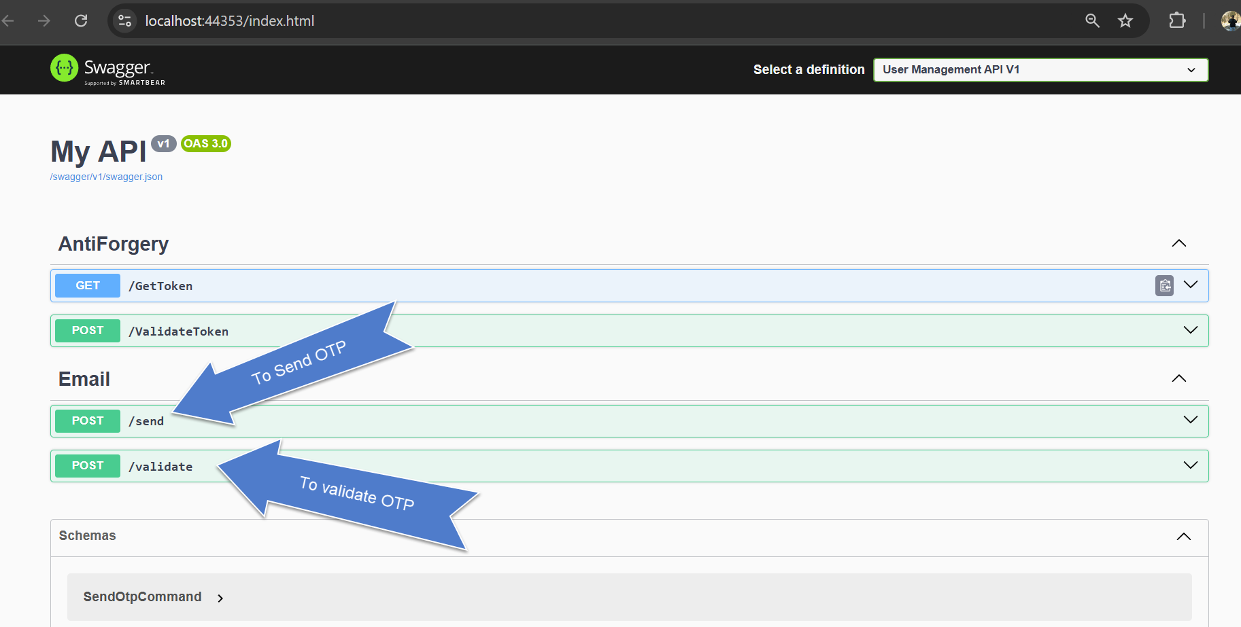

1. Send OTP.

API: <https://localhost:44353/send>

HTTP: POST

Body: {

    "email":"rishu@dso.org.sg"

}

Response : 200 OK | Email sent successfully!

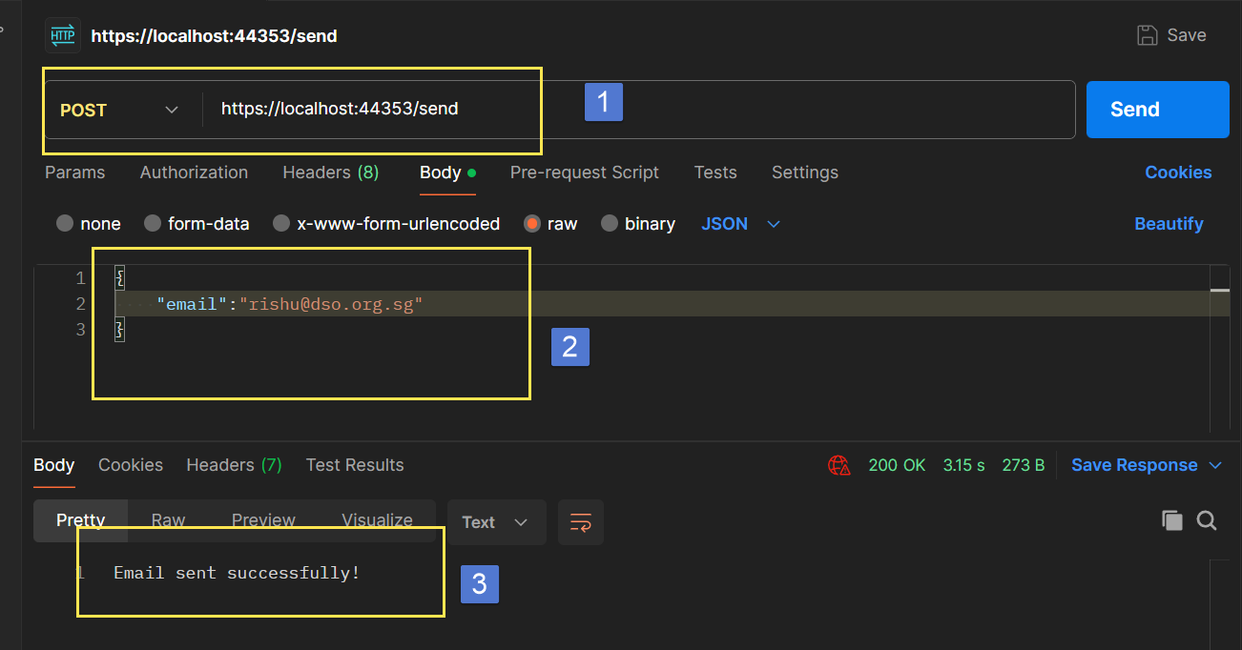

Email received:

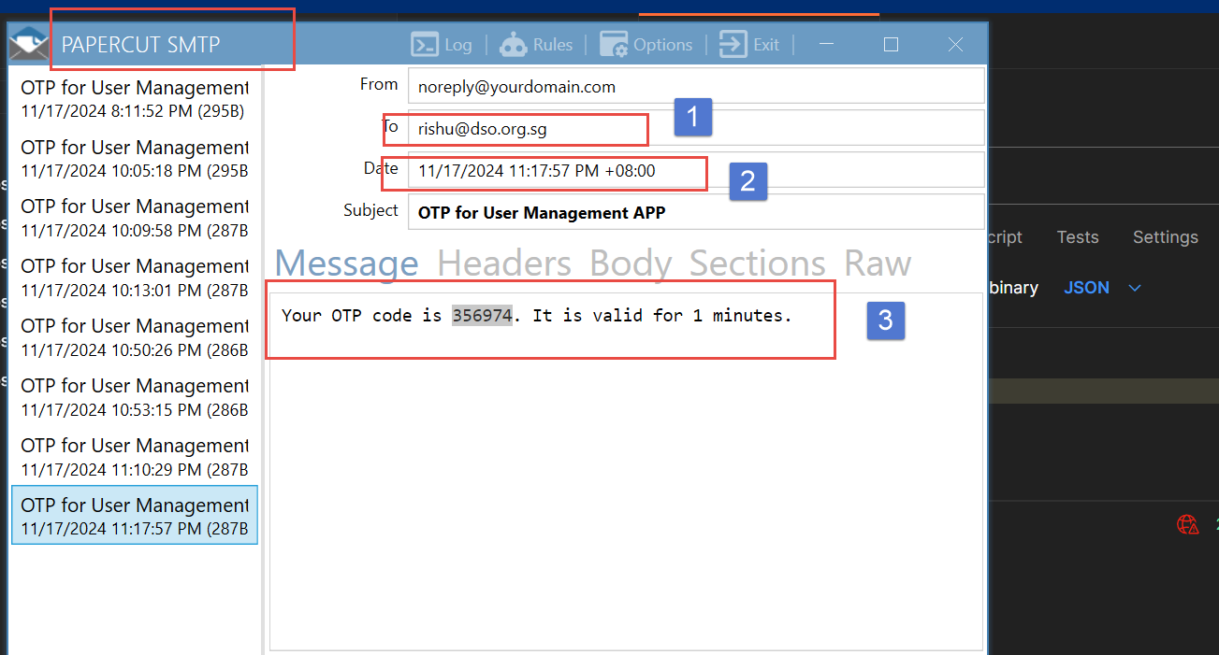

1. Validate email

API: https://localhost:44353/validate,

HTTP: POST

Body: {

    "email":”[rishu@dso.org.sg](mailto:rishu@dso.org.sg)”,

“code”:”356974”

}

Response: 200 OK | Email sent successfully!

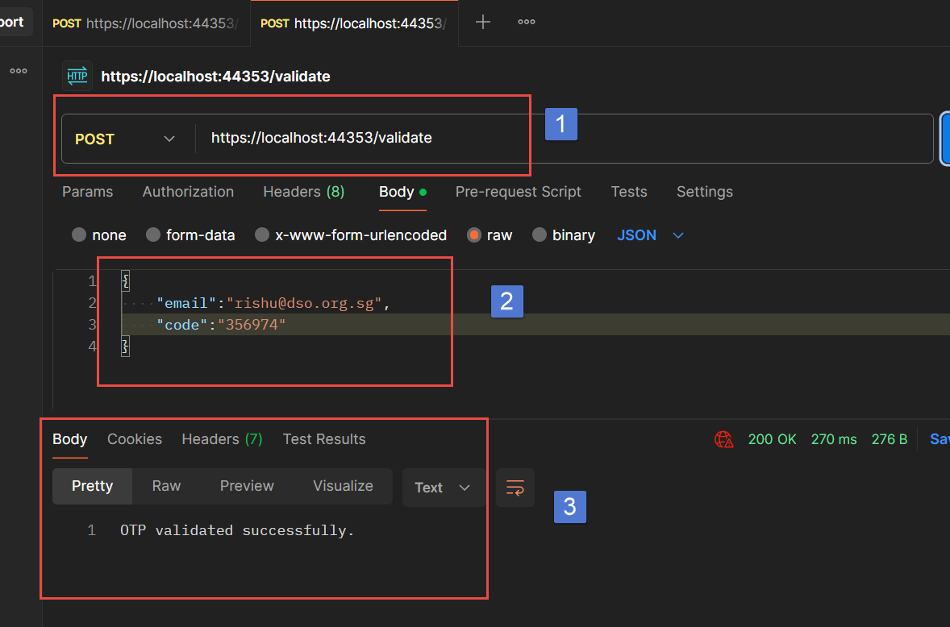

Email Validations:

1. If email format is not correct in /send or /validate api, response will be as follow:1

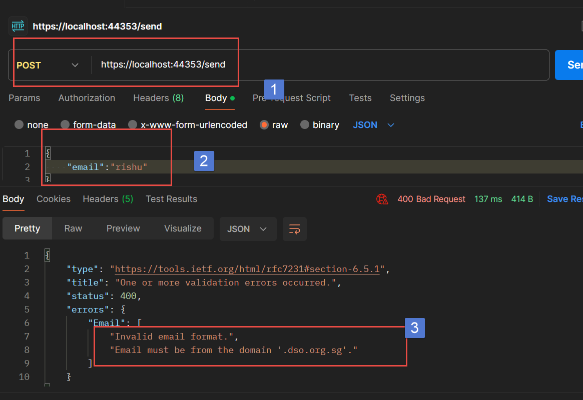

1. If email format is correct, but domain is not correct.

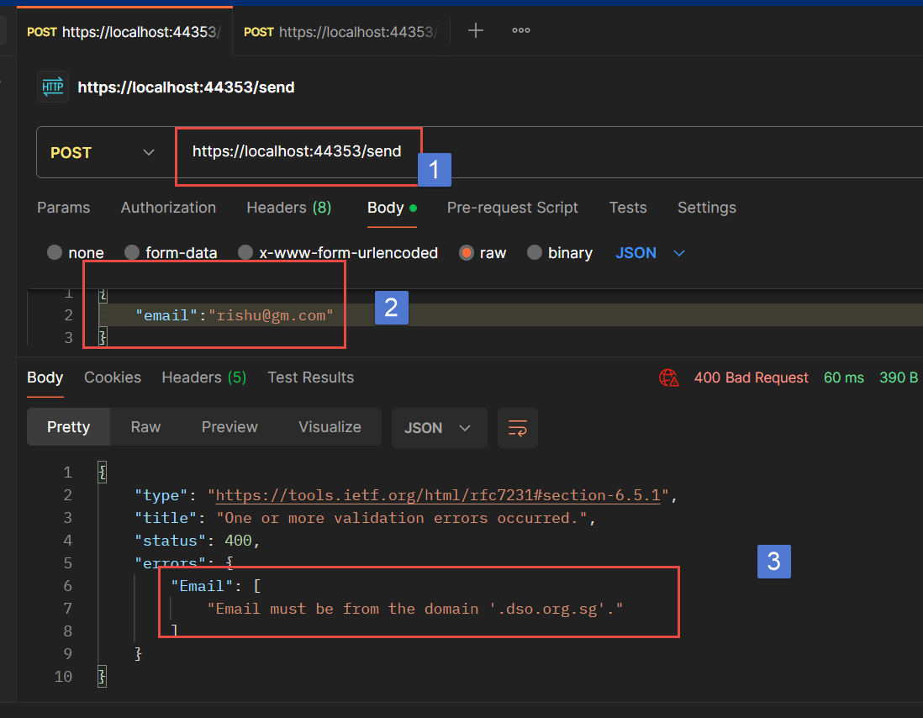

1. If email address is blank

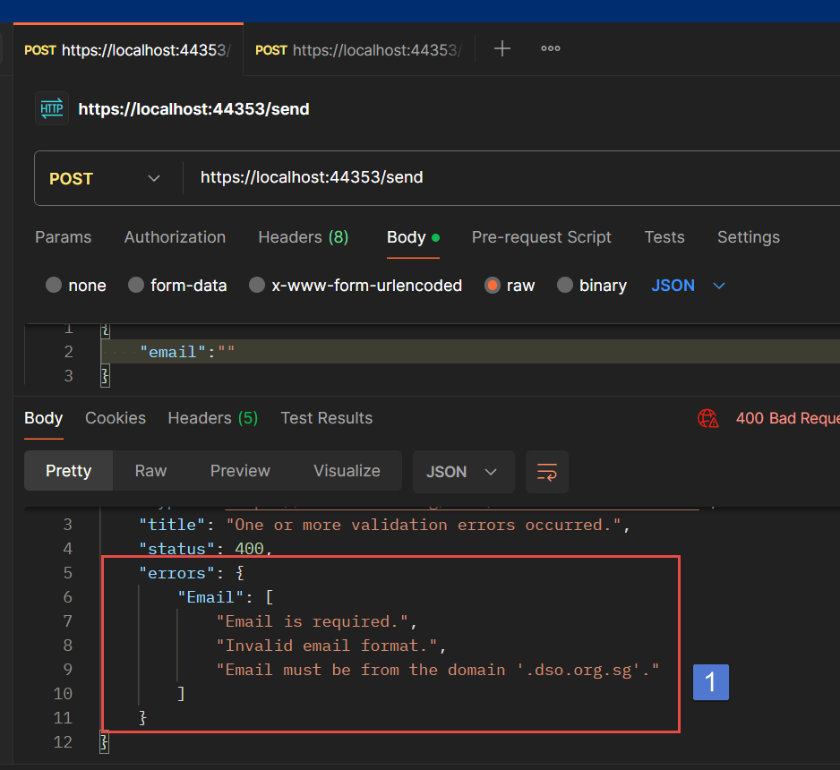

1. If Code is blank in /validate api

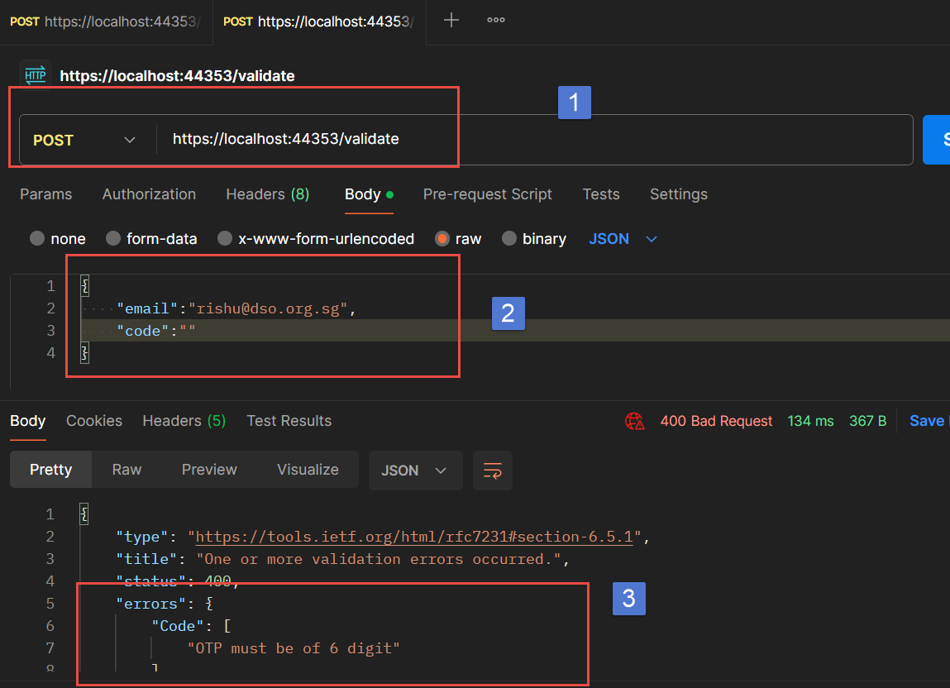

1. If Otp is retried after 1 min, even if it valid:

